**COMPETITIORS ANALYSIS REPORT :**

FASHION E-COMMERCE COMPANY

Myntra is a one stop shop for all your fashion and lifestyle needs. Being India's largest e-commerce store for fashion and lifestyle products, Myntra aims at providing a hassle free and enjoyable shopping experience to shoppers across the country with the widest range of brands and products on its portal. The brand is making a conscious effort to bring the power of fashion to shoppers with an array of the latest and trendiest products available in the country

MYNTRA’S MARKETING APPROACH: AN OVERVIEW

Myntra marketing strategy is a blend of several components, each contributing to the firm’s overall success. These include content marketing, social media marketing, search engine optimization (SEO), paid advertising, email marketing, affiliate marketing, and influencer marketing

1. CONTENT MARKETING STRATEGY

Myntra maintains an active blog covering a wide array of fashion-related topics. The blog features original content, as well as curated content from multiple sources, broadening its appeal to diverse audience segments. New posts are published several times a week, keeping the audience engaged and updated.

1. SOCIAL MEDIA MARKETING STRATEGY

Myntra social media strategy involves maintaining an active presence on all major platforms, including Facebook, Twitter, and Instagram. It uses these platforms to share links to new blog posts, announce sales and discounts, and promote new products.

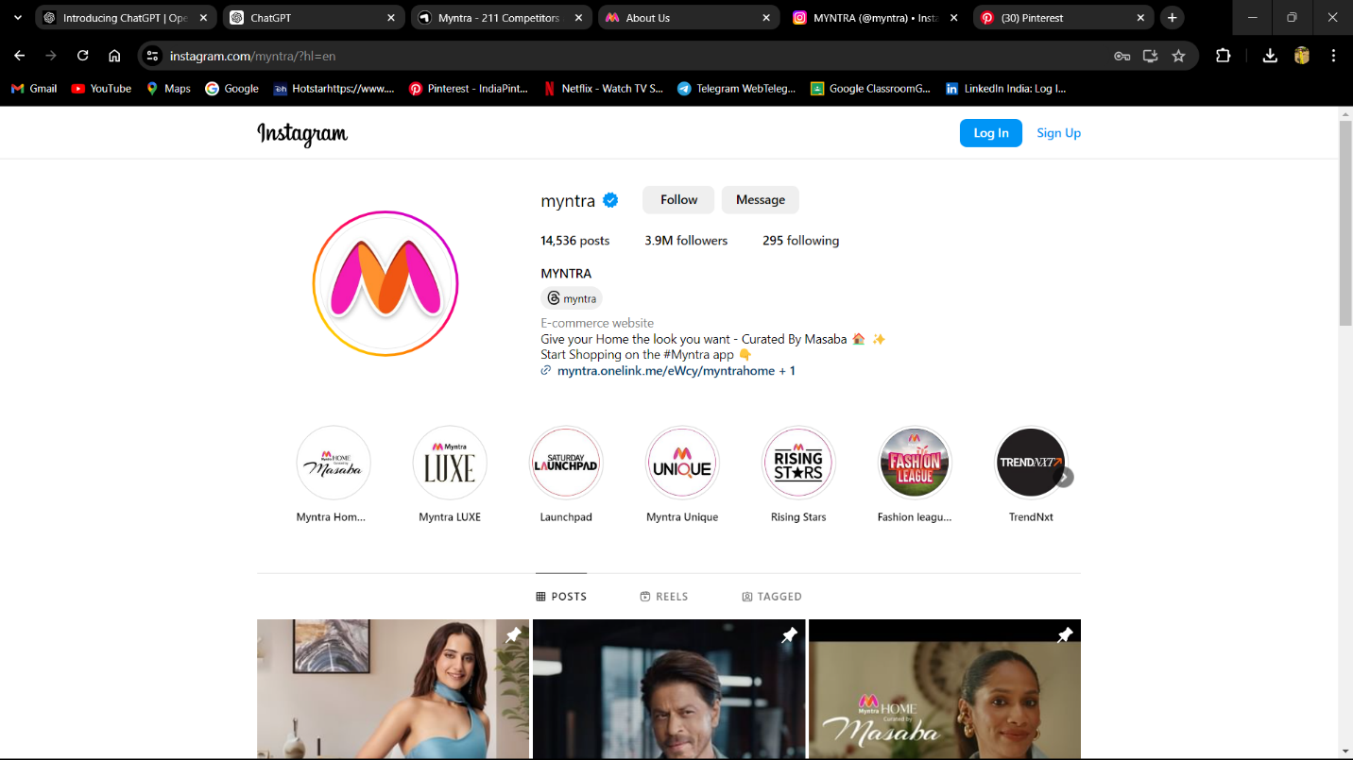

1. SEARCH ENGINE OPTIMIZATION (SEO) STRATEGY

Myntra employs SEO strategies to ensure its website ranks high in search results for relevant keywords. This involves using relevant keywords and phrases in site content, tags, and descriptions for each page. Myntra also has numerous backlinks from high-quality websites, further enhancing its [SEO](https://thirdeyeblindproductions.com/seo-services-company-mumbai/) ranking.

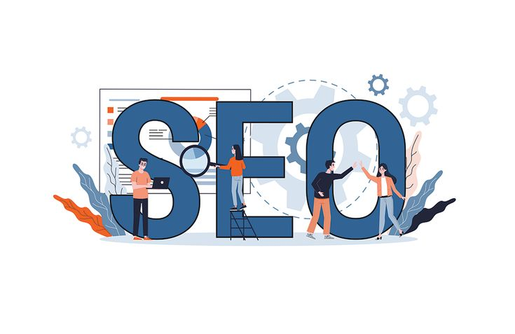

TOP 3

COMPETITORS OF MYNTRA

AJIO, a fashion and lifestyle brand, is Reliance Retail’s digital commerce initiative and is the ultimate fashion destination for styles that are handpicked, on trend and at prices that are the best you’ll find anywhere.

Celebrating fearlessness and uniqueness, Ajio is constantly looking to bring a fresh, current and accessible perspective to personal style.

At the heart of it all, Ajio’s philosophy and initiatives point to one simple truth – inclusivity and acceptance as the only way to make our society a little more humane. And along the way, just a little more stylish, whether it’s through creating capsule collections that make putting together great looks easy, making exclusive international brands available in one place, reviving India’s rich textile heritage through the Indie collection or making great style an easy purchase through the in-house brand AJIO Own.

AJIO Marketing Strategy

* A person sitting on a ladder

  Description automatically generatedA person sitting on the floor with her eyes closed

  Description automatically generatedContent marketing is another integral aspect of AJIO’s strategy. By producing high-quality content that resonates with its audience, AJIO establishes itself as a trusted fashion advisor. The company also leverages social media advertising and influencer collaborations to amplify its brand message and engage with customers on a deeper level. Moreover, AJIO recognizes the importance of SEO optimization in improving online visibility and attracting organic traffic.

**Ajio Website Traffic by Country**

See the global distribution of visitors to your competitor’s website and start tapping into overlooked markets. Ajio.com's core audience is located in India followed by United States, and United Kingdom.

|  |
| --- |
|  |
| | Country |  | All devices | Desktop | Mobile | | --- | --- | --- | --- | --- | | [India](https://www.semrush.com/website/top/india/all/) | 95.78% | 23.87M | 14.34% | 85.66% | | [United States](https://www.semrush.com/website/top/united-states/all/) | 0.91% | 227.53K | 67.17% | 32.83% | | [United Kingdom](https://www.semrush.com/website/top/united-kingdom/all/) | 0.43% | 108.36K | 46.64% | 53.36% | | [Canada](https://www.semrush.com/website/top/canada/all/) | 0.31% | 76.48K | 84.62% | 15.38% | | [United Arab Emirates](https://www.semrush.com/website/top/united-arab-emirates/all/) | 0.19% | 47.52K | 49.9% | 50.1% | |

**H & M Hennes & Mauritz AB** is a multinational clothing company based in Sweden that focuses on fash-fashion clothing. Hennes & Mauritz AB engages in the sale of clothing, accessories, footwear, cosmetics, and home textiles. The company products include accessories, underwear, cosmetics, sportswear, and other apparels for men, women, and kids. Its brands include H&M, COS, Monki, Weekday, & Other Stories, Cheap Monday, H&M Home, and ARKET. The

beauty and personal care in India, but also have been instrumental in fostering the growth of a previously relatively nascent ecosystem. From bringing you domestic brands, international brands, luxury and prestige brands, premium brands, niche and cult brands and expert advice and videos, coupled with our understanding of the needs and preferences of the consumers,to more than 72 Luxe and On-Trend and Kiosk Stores, an ever growing online community for beauty buffs, and a Beauty Helpline, we go out of our way to give you only the very best. With 2400+, 100% authentic brands Nykaa offers a well curated comprehensive selection of makeup, skincare, haircare, bath and body, fragrance, grooming appliances, personal care, and health and wellness categories.

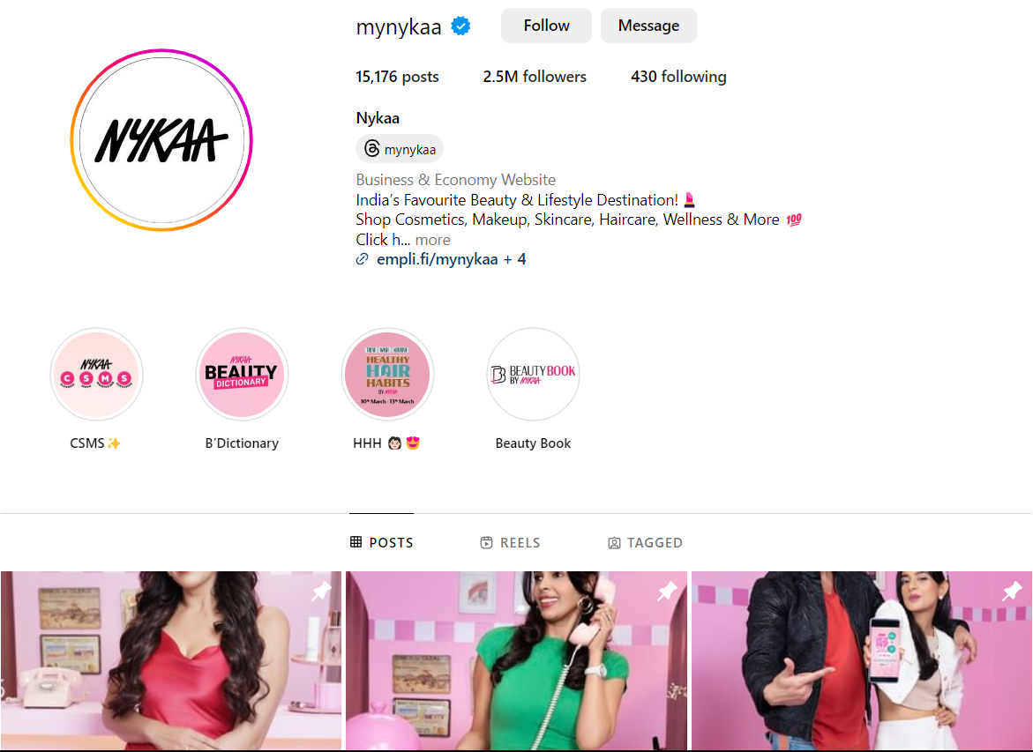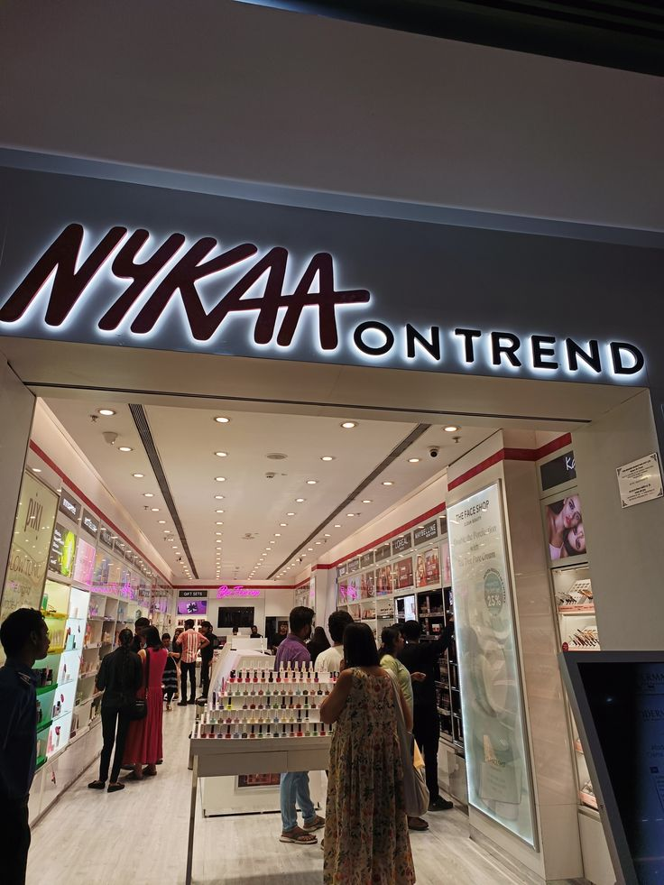

**Social Media Marketing**

The backbone of Nykaa’s digital marketing strategy is social media. It targets its social media’s audience by continuously engaging the people with their social media. From announcement of a new product to amazing deals, Nykaa has successfully grabbed everyone’s attention.

Impressively, Nykaa did not mixed up its different product line under on name on social media but created individual accounts for every product line that clearly define its niche and made it easy for the audience to reach out, what they’re looking for.

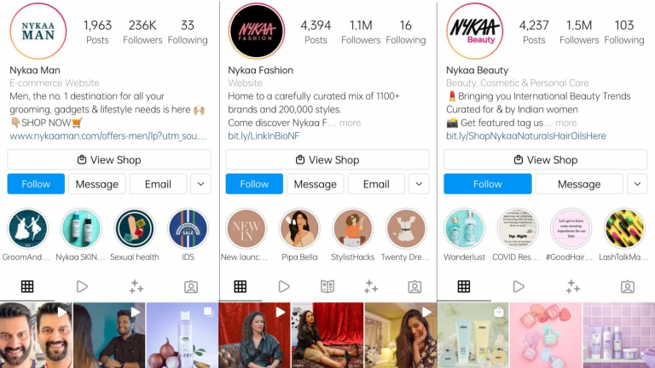

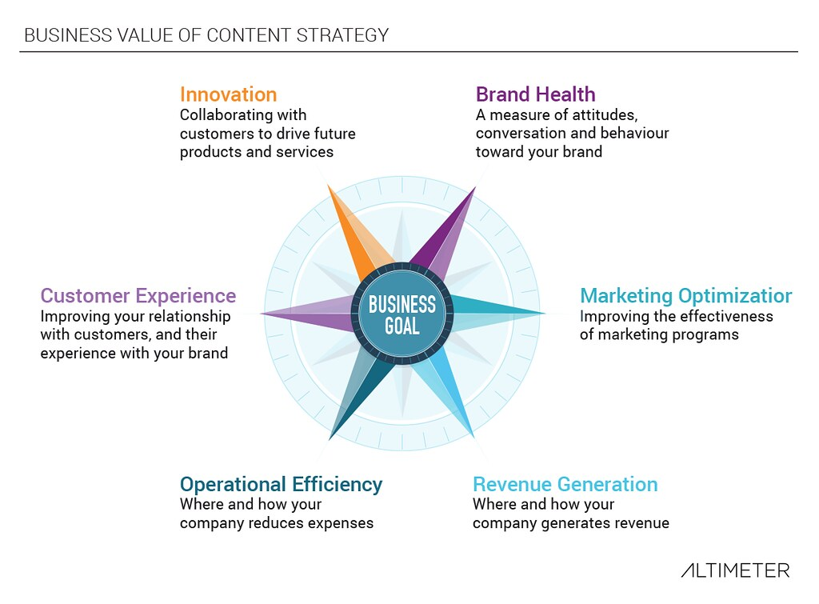Marketing strategies of Nykaa

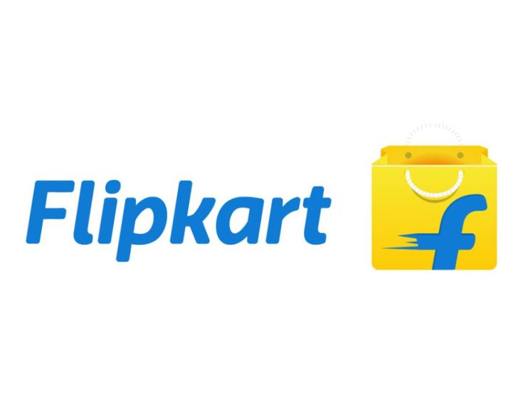

The Flipkart Group is one of India's leading digital commerce entities and includes group companies Flipkart, Myntra, Flipkart Wholesale, Flipkart Health+ and Cleartrip. The Group is also a majority shareholder in PhonePe, one of the leading Payments Apps in Indiam

Marketing strategies of Flipkart

1. **Captivating audiences**
2. **Digital marketing**
3. **Offline Promotion**

**COMPARATIVE REPORT OF MYNTRA WITH ITS COMPETITIORS [ H&M , FLIPKART, NYKAA]**

1. **Product Range**A hand holding a tablet

   Description automatically generated**Types of Watches**

|  |  |  |  |  |
| --- | --- | --- | --- | --- |
| Company | Analog | Digital | Smartwatches | Hybrid |
| Myntra | Yes | Yes | Yes | Yes |
| Flipkart | Yes | Yes | Yes | Yes |
| Nykaa | Limited | Limited | No | No |

1. **Product Lines and Collections**

|  |  |  |  |  |  |  |  |  |
| --- | --- | --- | --- | --- | --- | --- | --- | --- |
| |  |  | | --- | --- | | Company | Product Lines and Collections | | Myntra | Fashion accessories, apparel, footwear | | Flipkart | Diverse range of electronics, fashion, home essentials | | Nykaa | Beauty, wellness, and fashion products | |

1. **Technology and Innovation**
2. **Technological Advancements**

|  |  |  |  |  |  |  |  |  |
| --- | --- | --- | --- | --- | --- | --- | --- | --- |
| |  |  | | --- | --- | | Company | Technological Advancements | | Myntra | Augmented Reality (AR) for virtual try-ons, AI-driven recommendations | | Flipkart | AI and machine learning for personalized shopping experience, AR for product visualization | | Nykaa | Personalized beauty recommendations, virtual try-on for makeup | |

1. **Market Share**

|  |  |  |  |  |  |  |  |  |
| --- | --- | --- | --- | --- | --- | --- | --- | --- |
| |  |  | | --- | --- | | . | Market Share | | Myntra | 25% in the Indian fashion e-commerce market | | Flipkart | 35% in the Indian e-commerce market | | Nykaa | 10% in the Indian beauty and fashion e-commerce market | |

1. **Marketing and Advertising**

**Marketing Strategies**

|  |  |  |  |  |  |  |  |  |
| --- | --- | --- | --- | --- | --- | --- | --- | --- |
| |  |  | | --- | --- | | Company | Marketing Strategies | | Myntra | Social media campaigns, influencer marketing | | Flipkart | Festival sales, aggressive online marketing | | Nykaa | Influencer marketing, beauty tutorials, and reviews | |

**Final Comparisons Table and Insights**

|  |  |  |  |  |  |  |  |  |  |  |  |  |  |  |  |  |  |  |  |  |  |  |  |  |  |  |  |  |  |  |  |  |  |  |  |  |  |  |  |  |
| --- | --- | --- | --- | --- | --- | --- | --- | --- | --- | --- | --- | --- | --- | --- | --- | --- | --- | --- | --- | --- | --- | --- | --- | --- | --- | --- | --- | --- | --- | --- | --- | --- | --- | --- | --- | --- | --- | --- | --- | --- |
| | **Aspect** | **Myntra** | **Flipkart** | **Nykaa** | | --- | --- | --- | --- | | Founding Year | 2007 | 2007 | 2012 | | Headquarters | Bengaluru, India | Bengaluru, India | Mumbai, India | | CEO | Nandita Sinha | Kalyan Krishnamurthy | Falguni Nayar | | Product Range | Fashion, accessories | Diverse range | Beauty, wellness, fashion | | Technological Advancements | AR, AI recommendations | AI, AR | AR, personalized beauty recs | | Target Audience | Young adults, fashion enthusiasts | General consumers, tech-savvy | Beauty and fashion-conscious | | Price Range | $10 - $500 | $10 - $1000 | $5 - $300 | | Market Share | 25% Indian fashion e-commerce | 35% Indian e-commerce | 10% Indian beauty and fashion e-commerce | | Global Presence | India | India | India | |

**-Thank you**